From the airport, head straight (from car rental garage) until you get to a T-Junction, where you turn L and shortly thereafter R, following signs for France. This will take you through border control and then follow signs for A40/Chamonix/Milan/Turin.

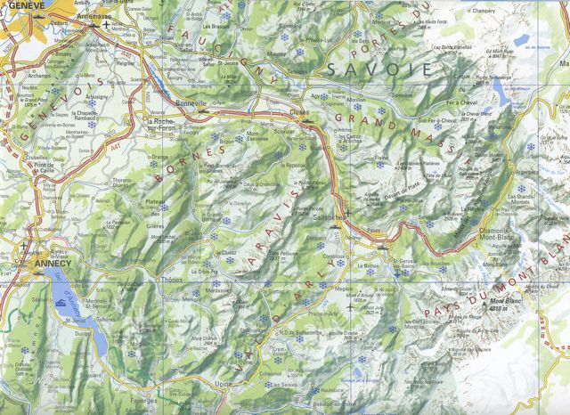
This is where you exit A40 @ J21

Keep on autoroute A40 as you pass round Geneva, following signs for Chamonix Mont Blanc onto the Autoroute Blanche:

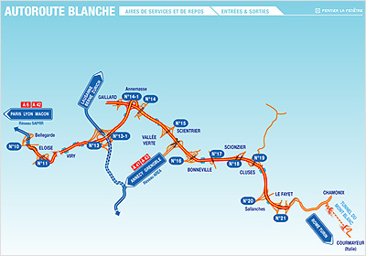

Stay on A40 to Junction 21, passing through 2 péages on the Autoroute ATMB (from memory at Bonneville (J16/J17) & Cluses (J19))

Just before J21, after the Mont Blanc and Aire de Passy-Mt Blanc sign (below)

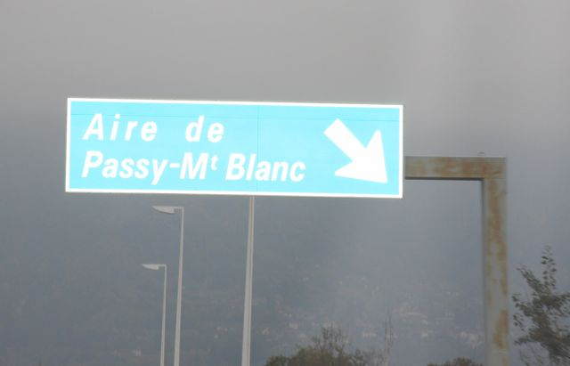

you will be warned that the exit is coming up – with a sign "Prochaine sortie Les Contamines Montjoie".

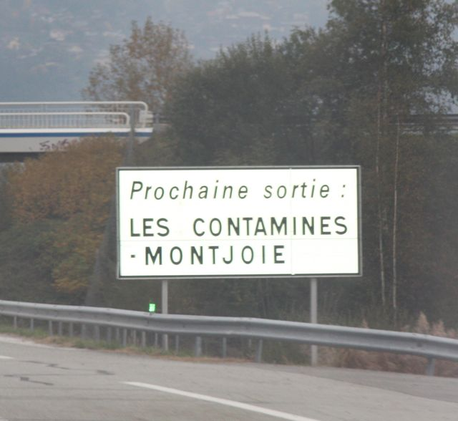

& then another sign, 1km before the exit (which doesn’t actually mention Les Contamines!):

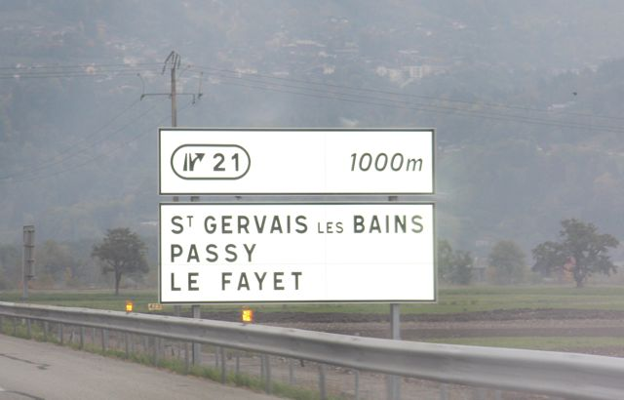

Shortly thereafter, the exit is signposted.

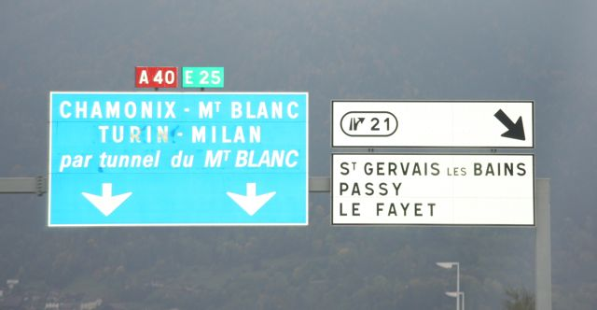

Exit A40 here at J21 & you will immediately see the sign below

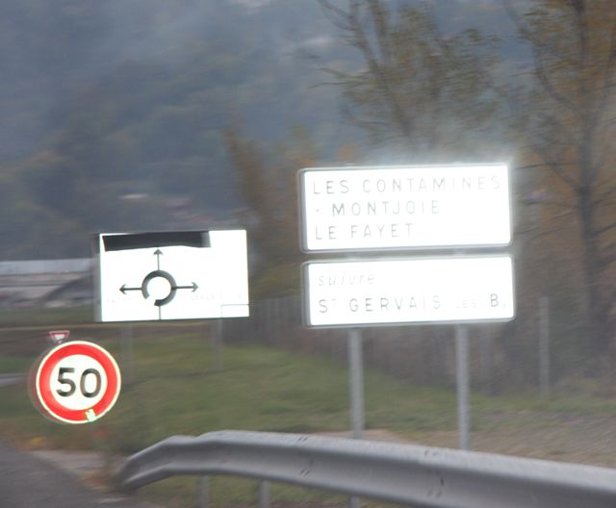

Turn R at end of slip road (onto D339) at the (new) roundabout, following signs for St. Gervais.

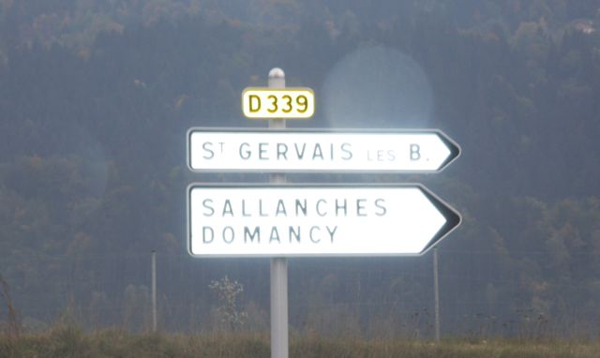

(awful photos, I know, but I was driving while I took these and the weather was closing in!)

At the next roundabout go straight over, then L at the one after that (actually a T-junction), following directions for St. Gervais/Les Contamines. (Those who prefer to turn R at T-junctions & roundabouts will end up in Sallanches!) You, hopefully, will have turned L.

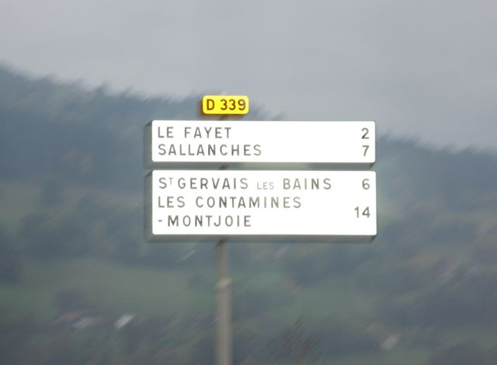

Go through Le Fayet, straight over all roundabouts, following the road as it turns sharp left (Parc Thermal entrance on R). Another roundabout appears quickly, so take first exit R at this roundabout, again following signs for St. Gervais/Les Contamines (either/or both). Drive up hill to St Gervais (Les Bains).

Go through centre of St Gervais and follow road round successive bends to L & R. Take the second exit off this roundabout (picture below) (opposite a Petit Casino supermarket, which is on your R)…

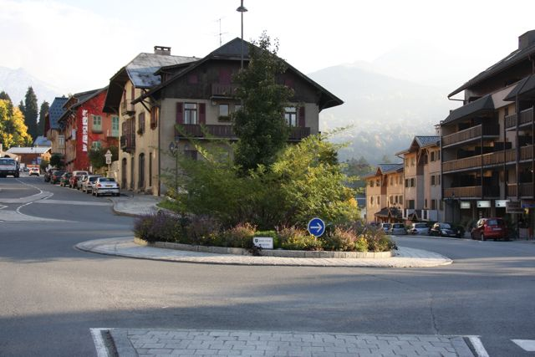

…that conveniently (!) has bushes growing in the middle of it to hide the sign below (which is the one you want to follow!)

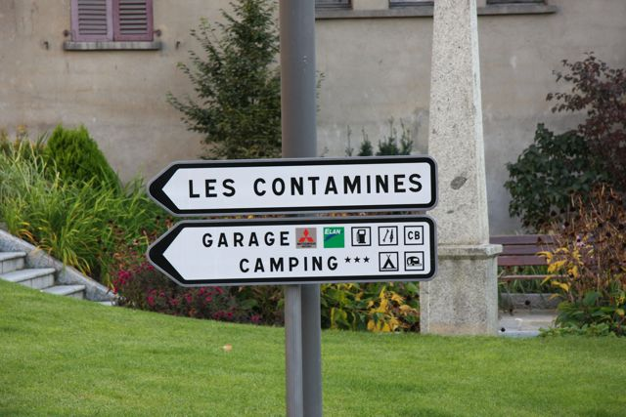

(DO NOT FOLLOW SIGN BELOW to Albertville, WHICH IS THE FIRST EXIT!)

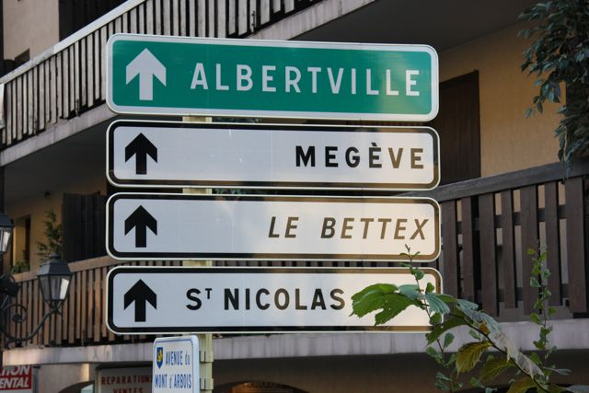

So, following the D902 to Les Contamines, leave St. Gervais behind you and head straight (up hill) to Les Contamines-Montjoie.

At Les Contamines

About 1km after you see the village sign, turn L at Banque Populaire, just as you arrive in the centre of the village (if you drive past Petit Casino on your L, you’ve missed the turning!). This is the Route de la Frasse, off which (eventually) is the drive of CK. Cassry on up the Route de la Frasse, round 2 tight bends (more than 90 degrees) and past the Hotel La Clef des Champs on R, continue round 3 more tight bends, and then the track to Chalet Kiana is the second on L, just below a big, old farm. There is a small sign under a wooden letterbox. Total distance from the Banque Populaire (start of Route de la Frasse) is just over 1 km (see route on picture on next page, with 5 hairpin bends marked out!)

This is what you’re looking for…

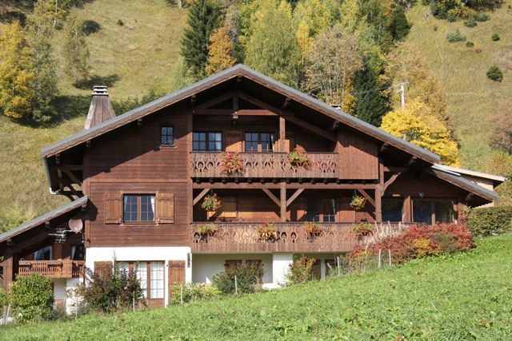

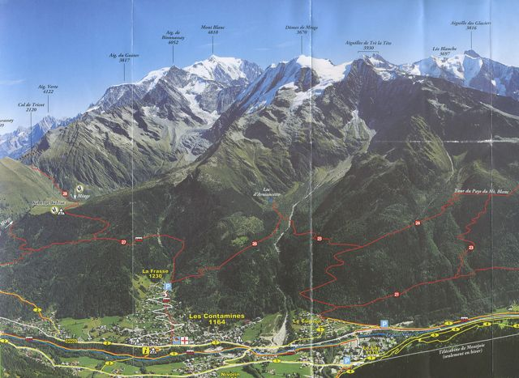
1
5
3
2
4
Chalet Kiana
Car park for nearest ski lifts – 5 mins.’ drive from CK

Chalet Kiana
1073 Route de la Frasse
74170 Les Contamines-Montjoie
Haute Savoie
France

Telephone (from UK mobile or from outside France): +33 450 543 165
Telephone (from within France): 04 50 54 31 65

DISTANCE FROM GENEVA AIRPORT: 100 kms
TIME FROM GENEVA AIRPORT: 75 mins

